

Rachel Z Trio

Everlasting
(Tone Center)

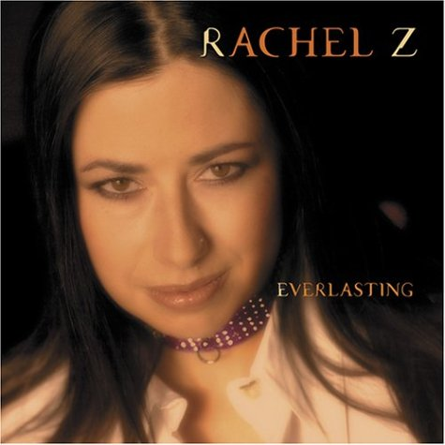
The concept of jazz musicians covering contemporary-pop tunes isn’t new – artists fro Louis Armstrong to Ramsey Lewis put their stamp on the hits of their day. Nor is it new to pianist Rachel Z (née Nicolzzo), whose last recording, 2003’s Moon at the Window, found her interpreting the songs of Joni Mitchell. On Everlasting, Z culls material ranging from jazzy pop tunes by Sting and Steely dan to grunge-rock anthems by Soundgarden and Smashing Pumpkins. Unlike their contemporaries in The Bad Plus who incorporate a heavy-rock dynamic into an acoustic-jazz setting, Z, bassist Tony Levin, and drummer Bobbie Rae keep the proceedings light, lyrical, and straightahead.

Everlasting starts with a sprightly version George Harrison’s “Here Comes the Sun,” an up-tempo romp that features some fine improvisational work from the pianist. Keeping the mood bright, the trio offers a straight read of Seal’s lovely “Kiss From a Rose,” which begins and ends with Levin’s skittering bowed bass. Other high points include exquisite renditions of June Carter Cash’s “Ring of Fire” and The Rolling Stones’ “Wild Horses,” both of which extrapolate on the songs’ memorable melodies and find new ways to express their statements of obsessive love. Soundgarden’s “Black Hole Sun” is refashioned into a lyrical dazzler, and her version of the Smashing Pumpkins’ “Tonight Tonight” also seems to tap the song’s emotional core.

While this is a bid for mainstream ears, Z and her trio’s interaction and improvisation mark them as true jazz artists. Only the most cynical jazz fan would dismiss this fine offering based on its pop pedigree alone.

Bob Weinberg
Jazziz July 2004

