LORRAINE FEATHER, Press Quotes
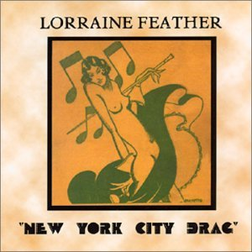
New York City Drag

“Feather did it at all… applied her witty way with a lyric to a set of vocalese numbers arching through the stunning complexities of Waller's piano lines… tricky inner rhymes, offbeat stories and sardonic references.”
- Don Heckman, Los Angeles Times

“Her stuff glitters and gleams and makes you think of Dorothy Parker and Norah Ephron...held the audience in the palm of her musicianly hand...”
- Tony Gieske, The Hollywood Reporter

“Melds the downtown hipness of Dave Frishberg with the uptown sophistication of Cole Porter...”
- Christopher Loudon, Jazz Times

“What a joy, what a delight, what a totally unexpected treat! [Feather’s lyrics] seem to shimmer between now and then…”
- Chip Deffaa, The New York Post

“Packs emotive whammy… glowingly pays tribute to Waller and his ilk.”- Zan Stewart, Down Beat

“Great jazz lyricists are not easy to find …Feather can turn a phrase with the best of them…utterly disarming.”
- Howard Reich, Chicago Tribune

“A RARE PLUG. Why? (1) Swing, wit, style (2) Swing (3) Wit (4) Style. Seriously... hip, hilarious, and beautifully done.” - The Steely Dan Newsletter (Donald Fagen and Walter Becker)

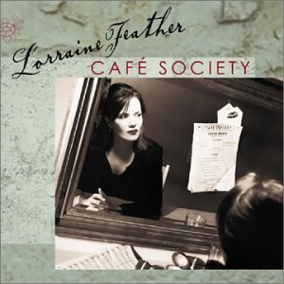
Cafe Society

“Exciting..impeccably performed..one of the freshest vocal releases you’ll hear all year.” –Ed Trefzger, Jazz Week

“Incisive lyrics deserve superb diction. Feather provides both. Don't let the word "diction" bother you. We're talking lightness and agility, not gravitas! I just can't wait until her next release.” – Bill Falconer, jazzreview.com

“Her voice is an innovative, calming yet exciting, warm and lived-in musical experience which I hope will be shared by many. I have worn out my copy of Cafe Society and have fallen in love with Lorraine Feather.” - Rex Reed

“Spirited high jinks..the sexy insouciance of Lee Wiley..a soaring salute to torchiness... remarkable...” – Christopher Loudon,
Jazz Times

“One of those ambitious ideas that actually worked out well. Feather has a pure, clean and expressive voice, and is confident throughout...Grade=A.” - Steve Eddy, Orange County Register

“[Her CDs] represent the most imaginative, impeccably composed and sung vocal jazz since the breakout of Lambert, Hendricks and Ross in the late 1950s/early 1960s era.”
- Phil Elwood, Jazz West

“As lyricist, as vocalist, as messenger, Lorraine Feather is a supreme storyteller in song.” - Leigh Kamman, The Jazz Image

“I came to listen to a few numbers but I couldn’t leave. She was like a lightning bolt,” - Joe Franklin, WOR New York

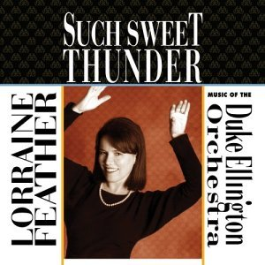

Such Sweet Thunder

“Energetic, enchanting and exceptional..she’s utterly comfortable and confident...sings her meticulous, clever poetry in a silvery, light voice...” Carol Sloane,
Down Beat

“Feather’s a natural storyteller...also a superb singer who gets the most out of every track.” – Ken Dryden,
All Music Guide

“It's a bit early, but here's my bid for Best Vocal Project of 2004— a significant appreciation of the Ellington/ Strayhorn oeuvre.” – Michael; Gladstone, All About Jazz

“Rises to new heights by taking a full length dive into Ellingtonia...genius. Pure genius.”–Christopher Loudon, Jazz Times [Top 10 List for 2004]

“The recordings of Lorraine Feather just better each time she records..the CD ranks at the top of the jazz vocal albums of 2004.” - Don Williamson, jazzreview.com

“Lorraine Feather writes poems for grownups and sings like a lark - a very hip lark!” – Al Van Starrex, Coda [Top Ten List for 2004]

“The album gets better every time I play it. She is a fine singer who puts over her songs with feeling, excellent diction, humour...what more could you want?” – Geoff Burdett, Crescendo

